**Versioning:**

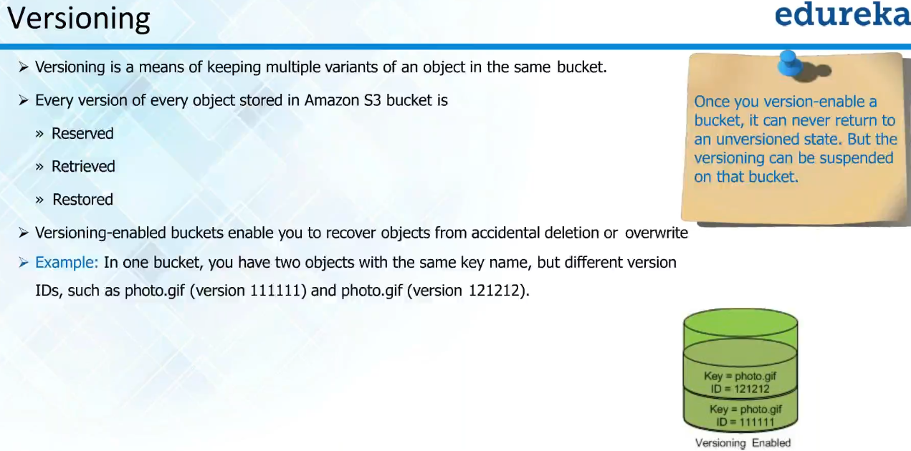

* Versioning will be useful for storing the code etc.
* It protects from accidental deletion also
* All the old versions of file will be stored in s3. So, at any time we can rollback to old version
* Amazon has edge server in all regions. If we are accessing the file from original server which is long distance, then when we access it, it keeps the copy of file in local edge server and makes it faster from next time

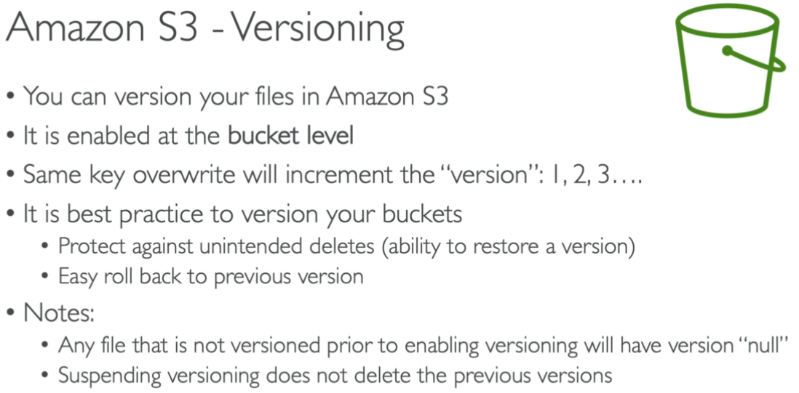

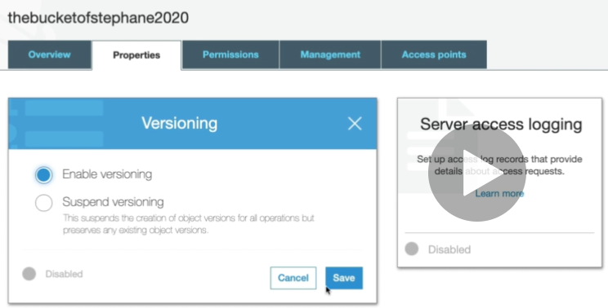

* We can enable the versioning as inside the properties of a bucket as above.

**Even if we suspend this versioning, then the old versions of files won’t be deleted.**

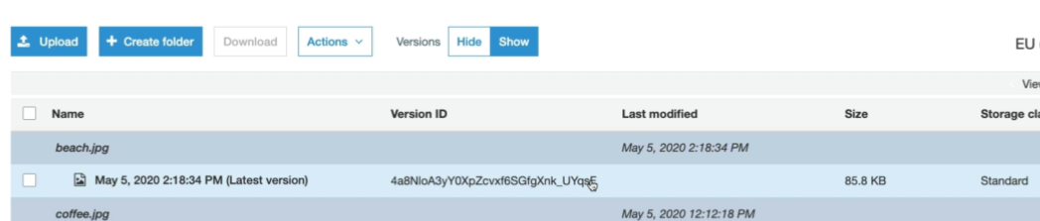

* Now, we can see the version ID created for the files we are uploading after we enable versioning for a bucket.

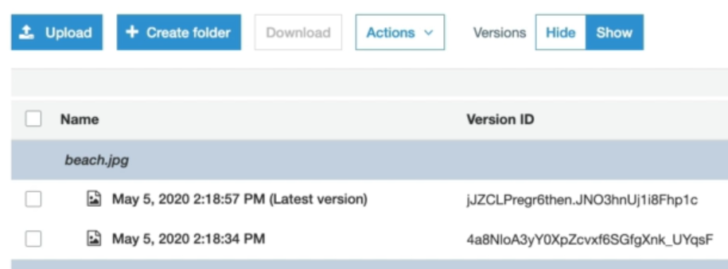

* If we upload the same file again, then the versioning will be created as above with latest tag and new version ID.

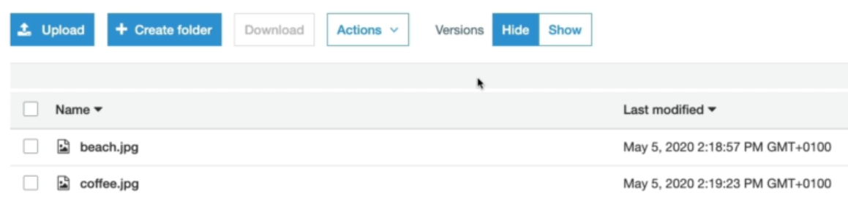

* If we go to version hide as above, it would show as just normal files.
* And if we delete that file here in hide window, the files will be gone. But we can still find the versions of that file in **show** versions window.

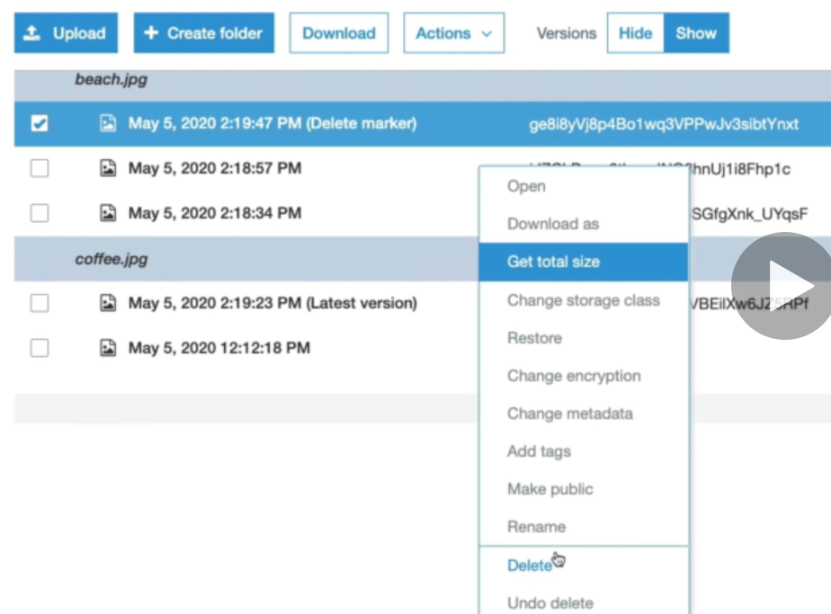

**Even the delete action would be marked in versioning. And if we delete that delete mark as above, then it will be reverted to normal version and we will be able to see the file again.**

**We can also delete a specific version ID just by selecting the version, right click on that and delete. Or we can select the restore option to restore to particular version**